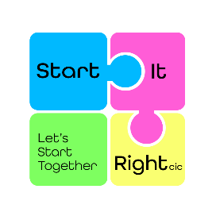
Partner Application Form

Prospective partners of Start It Right are required to complete this application form and return to: alexia@startitright.org.
All details will be kept in a secure database with access restricted to authorised officers only.
Section 1 – Main Contact information
In this section, please insert the persons contact details who will be leading on the partnership
Title | Mr Mrs Ms Miss
First Name |  | Surname:
Site/Location: |  | Job role:
 |  | Main contact number:
 |  | Mobile:
Town/City |  | Email address:
Post Code |  | Preferred name:
Section 2 – Organisation details
In this section, please insert the organisation the above person works for.
Company name |  | Email address:
Address |  | Post Code
 |  | Main contact number:
 |  | Town/City

Section 3 – Your support
In this section, please inform us how you intend to support. I am interested in…..
Becoming a partner
Becoming a member
Becoming a volunteer
Please give a brief explanation of your enquiry.

Section 4 – Publicity
In this section, please inform us if you are happy for your logo to be on our webpage and if you are happy to follow us on social media
Logo | Yes  No | Social Media | Yes  No
How did you hear about this opportunity

